**Beijing Jiaotong University**

**2021―2022 Computer Network Exercise Review**

-----------------------------------------------

**Part 1. Choose the CORRECT answers from the following choices.**

1. As the "storage - forward" network graph shown in Figure 1 below, the transmission rate of all links is 100 mbps, the MTU of all links is 1000 bytes. If the host H1 receives a 980000 bytes file from transport layer and will send to host H2, without considering grouping and propagation delay, from H1, at least it needs ___C___ to finish the transmission
2. 80ms
3. 80.08ms
4. 80.16ms
5. 80.24ms

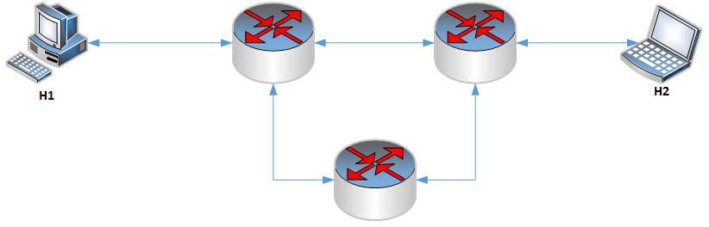

Figure 1

1. A TCP connection has been established between host A and host B. The host A has sent two consecutive TCP segments to host B, containing payloads of 300 and 500 bytes respectively. If the sequence number of the first segment from A starts with 200, after the host B receives the two segments correctly, the confirmation number in the acknowledgement it will send to the host A is ___D_____.
2. 500
3. 700
4. 800
5. 1000
6. Which of the following addresses exists in 10.48.0.0/12 ? ____A_____
7. 10.63.224.123
8. 10.64.65.216
9. 10.80.119.74
10. 10.96.206.154

**Part 2. Please fill the correct answers in the blanks**

1. In order to ensure reliable transmission in the data link layer, if the even parity method is used, what is the output for 11111000 after even parity__111110001_____.

-----------------------------------------------

**Part 4. Network Application Questions**

1. Host A sent two consecutive TCP segments to host B, with sequence numbers 100 and 170 respectively.

Please answer the following questions:

(1) How many bytes of data does the **first segment carry**? 70 bytes

(2) What should be the **confirmation number** in the acknowledgement sent back by host B after **receiving the first segment**? 170

(3) If the **ack** **confirmation number** returned by host B after receiving **the second segment is 200**, how many bytes of data are carried by the second segment sent by host A? 30 bytes

(4) If the second segment sent by host A is lost, but the first segment reaches B. B will send acknowledgement to A after the second segment arrives. What is the confirmation number? 170

1. Assume a router has established the following routing table:

Destination network Subnet mask Next hop

------------------------------------------------------------------

100.34.39.0 255.255.255.0 Interface 0

100.35.39.128 255.255.255.128 Interface 1

100.35.40.0 255.255.255.128 R2

50.31.153.0 255.255.255.192 R3

Default - R4

A total of 4 packets have been received, and their destination IP addresses are:

(1) 100.34.39.10 Interface 0;

(2) 100.35.39.126 R4;

(3) 100.35.40.126 R2;

(4) 50.31.153.48 R3;

Please try to calculate the next hop of each packet separately.

1. A company is assigned to an IP address with a CIDR 129.10.0.0/19. The company has 8,000 devices in total. They want to equally spread the devices across **8** **different locations**. If you are required to assign IP addresses for these devices. Please calculate **the subnet mask, minimum and maximum IP addresses of each location**.

|  |  |  |  |
| --- | --- | --- | --- |
| Location | Subnet Mask | Minimum IP | Maximum IP |
| 1 | 255.255.252.0 | 129.10.0.0 | 129.10.3.255 |
| 2 | 255.255.252.0 | 129.10.4.0 | 129.10.7.255 |
| 3 | 255.255.252.0 | 129.10.8.0 | 129.10.11.255 |
| 4 | 255.255.252.0 | 129.10.12.0 | 129.10.15.255 |
| 5 | 255.255.252.0 | 129.10.16.0 | 129.10.19.255 |
| 6 | 255.255.252.0 | 129.10.20.0 | 129.10.23.255 |
| 7 | 255.255.252.0 | 129.10.24.0 | 129.10.27.255 |
| 8 | 255.255.252.0 | 129.10.28.0 | 129.10.31.255 |

1. Here is a network structure of a network

MTU=1000

MTU=620

MTU=800

MTU=1500

MTU=1500

R1

R2

R3



Figure 3

If a 3000 bytes packet (IP header is included) will be sent from H1 to H2, following the route H1-R1-R2-H2.

1. **how many packets** will be arrived to H2 finally?
2. And what is the **Total length, DF, MF, Offset value of each packet**?

6 packets:

1. 5
2. 620, DF 0 MF 1 OFFSET 0;

620, DF 0 MF 1 OFFSET 600/8;

620, DF 0 MF 1 OFFSET 1200/8;

620, DF 0 MF 1 OFFSET 1800/8;

600, DF 0 MF 0 OFFSET 2400/8;

**Part 5. Network Analysis Questions**

1. Here is a network structure of a company.

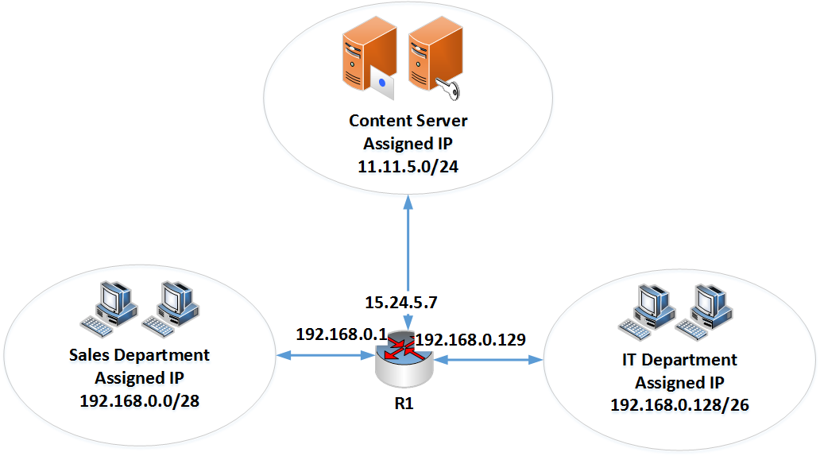

1. What is the IP broadcast address of Sales Department and IT Department?
2. If each host can be assigned with only 1 IP address, then what is the maximum hosts of IT Department?
3. If one host 192.168.0.5 from Sales Department wants to send a packet to a Content Server 11.11.5.7 outside the company, and the Server 11.11.5.7 will send back a reply to host 192.168.0.5. Please describe the whole transmission process **(including the source IP address and destination IP address)** and **what kind of technique** will be used in the transmission.
4. Sales:192.168.0.0-192.168.0.15

Broadcast:192.168.0.15

IT:192.168.0.128-192.168.0.191

Broadcast:192.168.0.191

1. IP addresses of IT: 192.168.0.128-192.168.0.191

Hosts:61/62

1. 192.168.0.5-192.168.0.1-NAT(port)-15.24.5.7-11.11.5.7

11.11.5.7-15.24.5.7-NAT(port)-192.168.0.1-192.168.0.5

NAT,ARP,TCP/IP

1. There are 4 hosts A, B, C and D in the same physical network.

The IP address of host A is 192.155.28.112;

the IP address of host B is 192.155.28.120;

the IP address of host C is 192.155.28.135;

and the IP address of host D is 192.155.28.202.

Their common subnet mask is 255.255.255.224.

Please answer the following questions:

1. Which ones of the 4 hosts (A, B, C and D) can communicate directly?
2. Which ones require a gateway (or router) to communicate?
3. Please draw a network diagram and indicate the subnet address and host address of each host.
4. A 5th host E is added. If we want E can communicate directly with D, what is the IP address range of E?
5. AB (in the subnet of 192.155.28.96-192.155.28.127)
6. C (in the subnet of 192.155.28.128-192.155.28.159) and D (in the subnet of 192.155.28.192-192.155.28.223)

A

192.155.28.112

B

192.155.28.120

C

192.155.28.135

D

192.155.28.202

1. (192.168.28.192-192.168.28.223)